## Declaration on Plagiarism

|  |  |
| --- | --- |
| **Name:** | Nikhil Mittal |
| **Student Number:** | 19210509 |
| **Programme:** | MCM in Computing(Data Analytics) |
| **Module Code:** | CA682 |
| **Assignment Title:** | Data Visualisation |
| **Submission Date:** | 13 Dec 2019 |
| **Module Coordinator:** | Dr Suzanne Little |

I declare that this material, which I now submit for assessment, is entirely my own work and has not been taken from the work of others, save and to the extent that such work has been cited and acknowledged within the text of my work. I understand that plagiarism, collusion, and copying are grave and serious offences in the university and accept the penalties that would be imposed should I engage in plagiarism, collusion or copying. I have read and understood the Assignment Regulations. I have identified and included the source of all facts, ideas, opinions, and viewpoints of others in the assignment references. Direct quotations from books, journal articles, internet sources, module text, or any other source whatsoever are acknowledged and the source cited are identified in the assignment references. This assignment, or any part of it, has not been previously submitted by me or any other person for assessment on this or any other course of study.

I have read and understood the referencing guidelines found at <http://www.dcu.ie/info/regulations/plagiarism.shtml>, <https://www4.dcu.ie/students/az/plagiarism> and/or recommended in the assignment guidelines

Name: Nikhil Mittal Date: 13/12/2019

**Global Terrorism**

**Abstract**

Global terrorism is terrorism on a worldwide scale. Terrorism is criminal violence inflicted upon innocent bystanders. World terrorism has been on the rise since 1970 with around 180,000 attacks so far. With the data, I wanted to see which region is most affected by terrorism, how it has affected the countries and the number of killings in each country since 1970 and what are the most common attack types that happened over the course. The conclusion reached is that the Middle East and Sub-African regions have been most affected by terrorism with almost 20,000 killings in the year 2014. The country most affected by terrorism over the years are Iraq, Afghanistan, and Nigeria with having the most killings over the period. Most killings with the attack type are Armed Assault and Bombing /Explosion over the same years i.e. from 1970-2017.[7][8]

**Dataset**

* The database is maintained by researchers at the National Consortium for the Study of Terrorism and Responses to Terrorism (START), headquartered at The University of Maryland. The size of the data is 158 MB.
* This dataset contains a lot of terrorism information for various regions with the country most affected year-wise from 1970 to 2017. There are 181691 rows and 135 columns with attributes like date, time, location, number of hostages killed, wounded, if a ransom existed, the result, if a suicide attack existed, claims, weapons used.[2]
* The dataset has the big data quality of volume as it has 181691 records with 47 years of data being recorded.[2]
* The data was retrieved from the Kaggle website(<https://www.kaggle.com/START-UMD/gtd>).

**Data Processing and Cleaning**

For Nkill

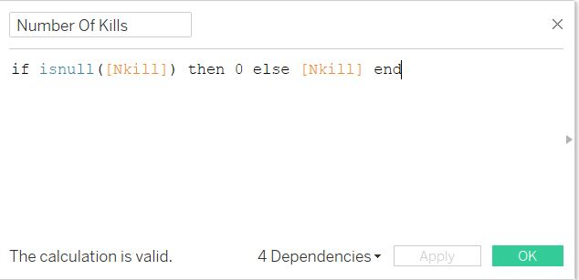

Figure:1

To prepare the dataset I removed the null values from Nkill attribute by making a calculated field of Nkill from the data source and changed attribute name to the number of kills. It helped me showed which country is most affected by terrorism when the graph is plotted with the number of kills.

For Iyear

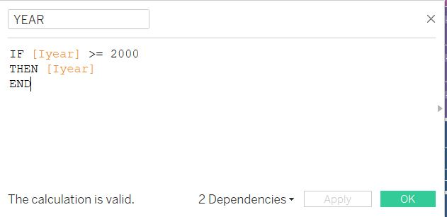

Figure : 2

I removed the years before 2000 so that filtering can be done easily, and the graph looks presentable.

I chose the attributes for visualization because they gave the best possible explanation to the graph type I chose as the attribute values provide the information generated by visualization.

**Flow of Creation**

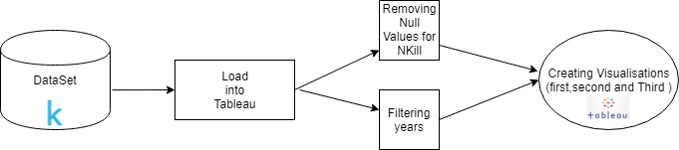

Figure: 3

**Visualization**

Line Graph

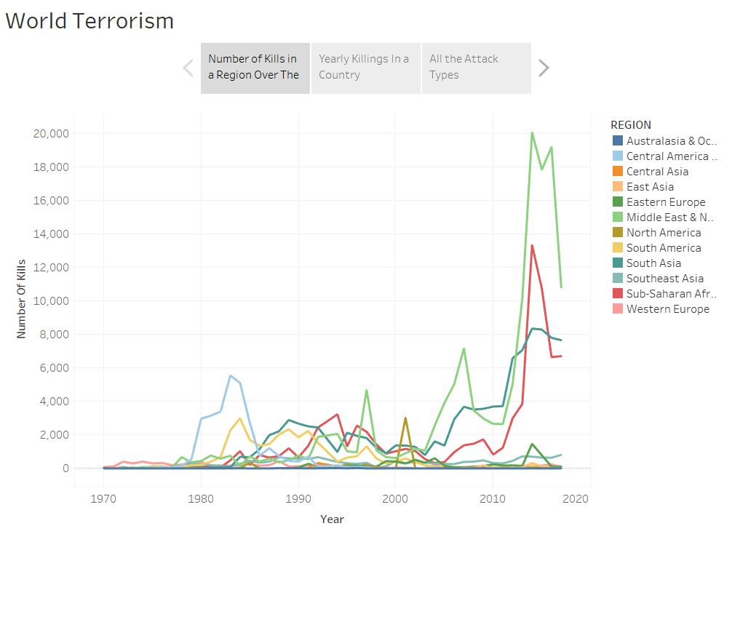

*Figure:4*

This is the first graph which is “Line Graph” which tells which region in the globe for a 10-year time span has the most number of kills. It tells the region that has been most affected by terrorism in these years*.*

Tree Map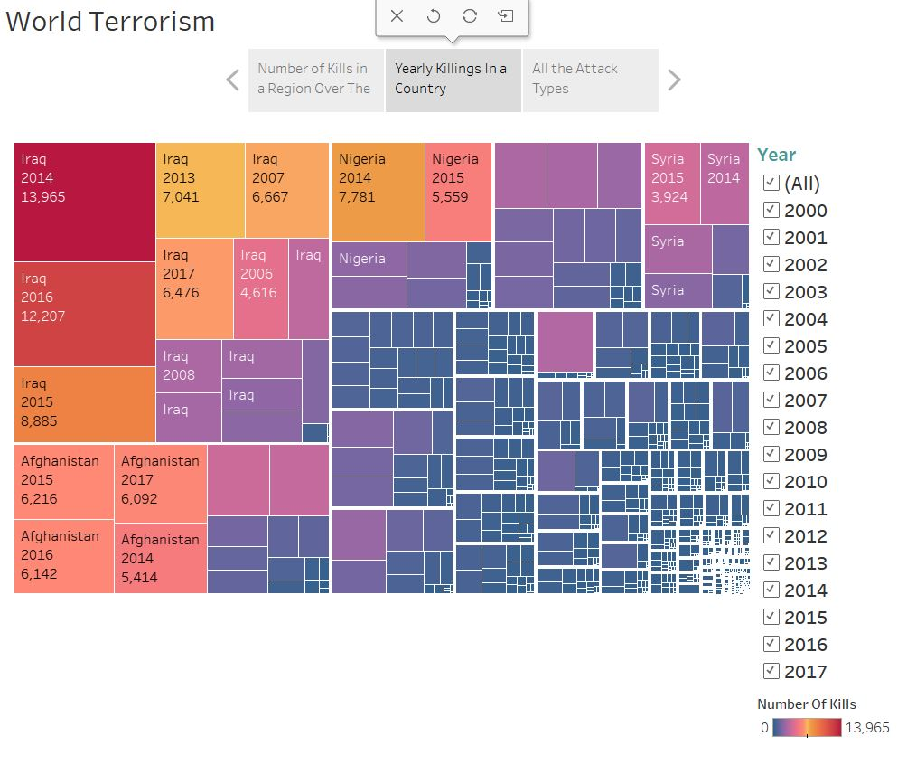

Figure:5

This is a ”Tree Map” which shows which country has the most killings for a year. We can filter the year to get a particular year and the total killings for that year. I used the Sunrise-Sunset Colour choice for this visualization

Word Cloud

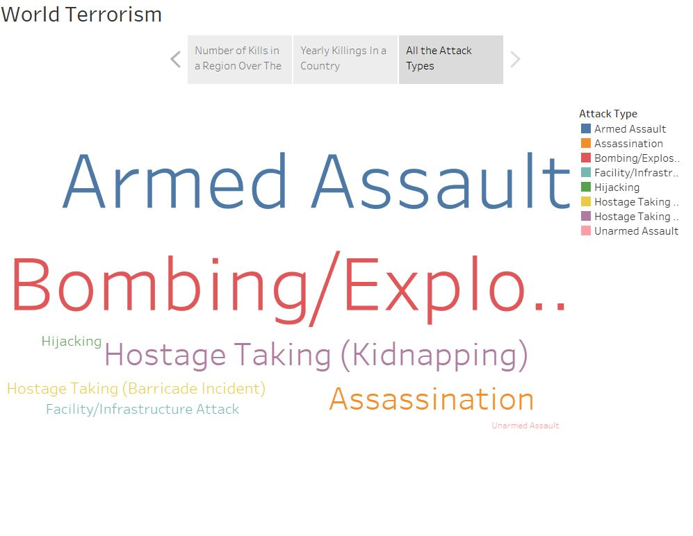

Figure:6

This is a “Word Cloud” visualization of attack types which tells which attack type has the most number of kills. I used Word Cloud because it tells in big words which particular has the most impact or was recorded .

**Inference on Visualisation**

* For the Firstline graph, it can be inference that the Middle east and North Africa Region has the most number of killings which is about 20,080 for the year 2014.
* For the Tree Map, it can be concluded that Iran and then Afghanistan are the countries most affected by Terrorism with having the most number of killings and if we want to select a particular year from the filter for example if only 2001 is selected it is shown that United States has 3008 kills that year which is because of the 9/11 attacks.
* And for the Word Cloud, it can be said that Armed Assault and Bombing/Explosion Played a Major Role in the killings with the highest number*.*

**Conclusion**

* I used Tableau Workbook to visualize the dataset.
* To remove null values via Tableau was a bit challengeable.
* Animation in the Line Graph would have made the visualization more suitable.
* I wanted to showcase Maps in the visualization but there were too many countries and maps where getting untidy.
* I wanted to show Packed Bubbles instead of Word cloud, but packed bubbles weren’t showing the attribute information inside the bubble.
* I wanted to arrange Word Cloud according to most number but couldn’t do so because the difference was less between the first two.
* I created a Story in the Tableau instead of Dashboard because dashboard was making the Visualisations small and untidy & couldn’t see the whole information.

**References**

[1] <https://www.kaggle.com/START-UMD/gtd>

[2] <https://www.kaggle.com/gpreda/global-terrorist-attacks>

[3] <https://help.tableau.com/current/pro/desktop/en-us/datafields_specialvalues.htm>

[4] <https://community.tableau.com/docs/DOC-6244>

[5] <https://community.tableau.com/thread/270713>

[6] <https://www.youtube.com/watch?v=lT3WJ4PbBow>

[7] <https://www.start.umd.edu/research-projects/global-terrorism-database-gtd>

[8] <https://www.longdom.org/abstract/terrorism-in-the-world-13235.html>